EJERCICIOS ENRUTAMIENTO
PLANIFICACIÓN Y ADMINISTRACIÓN DE REDES LOCALES – ASIR1
Ejercicio 1
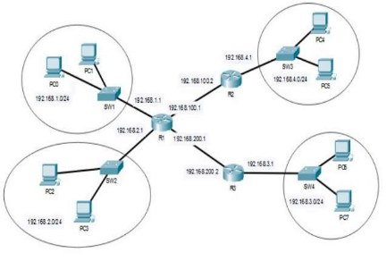

ROUTER 1
DIR. RED | MÁSCARA | SALIDA | PROX. SALTO | MÉTRICA
192.168.2.0/23 | 255.255.255.254 | fa0/0 | 192.168.200.2 | 0
192.168.1.0/24 | 255.255.255.0 | fa0/1 | - | 0
192.168.4.0/24 | 255.255.255.0 | fa0/2 | 192.168.100.2 | 1
192.168.200.0/30 | 255.255.255.252 | fa0/3 | - | 0
192.168.100.0/30 | 255.255.255.252 | fa0/2 | - | 0

Interfaces R1:
Fa0/0: (192.168.2.1)
Fa0/1: (192.168.1.1)
Fa0/2: (192.168.100.1)
Fa0/3: eth200 – 192.168.200.1

ROUTER 2
DIR. RED | MÁSCARA | SALIDA | PROX. SALTO | MÉTRICA
192.168.4.0/24 | 255.255.255.0 | fa0/0 | - | 0
192.168.100.0/30 | 255.255.255.252 | fa0/1 | - | 0
192.168.1.0/24 | 255.255.255.0 | fa0/1 | 192.168.100.1 | 1
192.168.2.0/24 | 255.255.255.0 | fa0/1 | 192.168.100.1 | 1
192.168.200.0/30 | 255.255.255.252 | fa0/1 | 192.168.100.1 | 1
192.168.3.0/24 | 255.255.255.0 | fa0/1 | 192.168.100.1 | 1

Interfaces R2:
Fa0/0: (192.168.4.1)
Fa0/1: (192.168.100.2)

ROUTER 3
DIR. RED | MÁSCARA | SALIDA | PROX. SALTO | MÉTRICA
192.168.3.0/24 | 255.255.255.0 | fa0/0 | - | 0
192.168.200.0/30 | 255.255.255.252 | fa0/1 | - | 0
192.168.2.0/24 | 255.255.255.0 | fa0/1 | 192.168.200.1 | 1
192.168.1.0/24 | 255.255.255.0 | fa0/1 | 192.168.200.1 | 1
192.168.100.0/30 | 255.255.255.252 | fa0/1 | 192.168.200.1 | 1
192.168.4.0 | 255.255.255.0 | fa0/1 | 192.168.200.1 | 1

Interfaces R3:
fa0/0: 192.168.3.1
fa0/1: 192.168.200.2
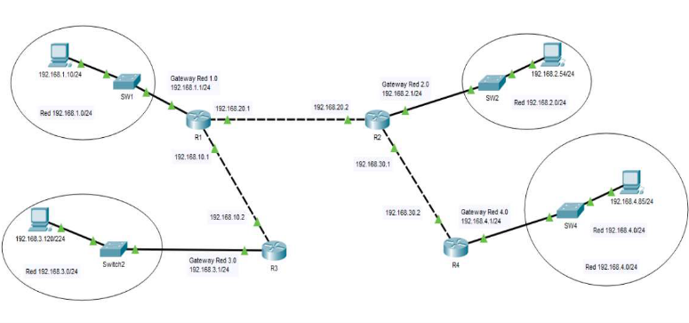
Ejercicio 2

ROUTER 3
DIR. RED | MÁSCARA | SALIDA | PROX. SALTO | MÉTRICA
192.168.3.0/24 | 255.255.255.0 | fa0/0 (192.168.3.1/24) | - | 0
192.168.10.1/24 | 255.255.255.0 | fa0/1 (192.168.10.2) | - | 0
192.168.1.0/24 | 255.255.255.0 | Fa0/1 | 192.168.10.1 | 1
192.168.20.2/24 | 255.255.255.0 | Fa0/1 | 192.168.10.1 | 1
192.168.2.0/24 | 255.255.255.0 | Fa0/1 | 192.168.10.1 | 2
192.168.30.2/24 | 255.255.255.0 | Fa0/1 | 192.168.10.1 | 2
192.168.4.0/24 | 255.255.255.0 | Fa0/1 | 192.168.10.1 | 3

ROUTER 1
DIR. RED | MÁSCARA | SALIDA | PROX. SALTO | MÉTRICA
192.168.1.0/24 | 255.255.255.0 | fa0/0 (192.168.1.1/24) | - | 0
192.168.10.2/24 | 255.255.255.0 | fa0/1 (192.168.10.1) | - | 0
192.168.3.0/24 | 255.255.255.0 | Fa0/1 | 192.168.10.2 | 1
192.168.20.2/24 | 255.255.255.0 | Fa0/3 (192.168.20.1) | - | 0
192.168.2.0/24 | 255.255.255.0 | Fa0/3 | 192.168.20.2 | 1
192.168.30.2/24 | 255.255.255.0 | Fa0/3 | 192.168.20.2 | 1
192.168.4.0/24 | 255.255.255.0 | Fa0/3 | 192.168.20.2 | 2

ROUTER 2
DIR. RED | MÁSCARA | SALIDA | PROX. SALTO | MÉTRICA
192.168.2.0/24 | 255.255.255.0 | fa0/0 (192.168.2.1/24) | - | 0
192.168.30.2/24 | 255.255.255.0 | fa0/1 (192.168.30.1) | - | 0
192.168.4.0/24 | 255.255.255.0 | Fa0/1 | 192.168.30.2 | 1
192.168.20.1/24 | 255.255.255.0 | Fa0/3 (192.168.20.2) | - | 0
192.168.1.1/24 | 255.255.255.0 | Fa0/3 | 192.168.20.1 | 1
192.168.10.2/24 | 255.255.255.0 | Fa0/3 | 192.168.20.1 | 1
192.168.3.0/24 | 255.255.255.0 | Fa0/3 | 192.168.20.1 | 2

ROUTER 4
DIR. RED | MÁSCARA | SALIDA | PROX. SALTO | MÉTRICA
192.168.4.0/24 | 255.255.255.0 | fa0/0 (192.168.4.1/24) | - | 0
192.168.30.1/24 | 255.255.255.0 | fa0/1 (192.168.30.2) | - | 0
192.168.2.0/24 | 255.255.255.0 | Fa0/1 | 192.168.30.1 | 1
192.168.20.1/24 | 255.255.255.0 | Fa0/1 | 192.168.30.1 | 1
192.168.1.0/24 | 255.255.255.0 | Fa0/1 | 192.168.30.1 | 2
192.168.10.2/24 | 255.255.255.0 | Fa0/1 | 192.168.30.1 | 2
192.168.3.0/24 | 255.255.255.0 | Fa0/1 | 192.168.30.1 | 3

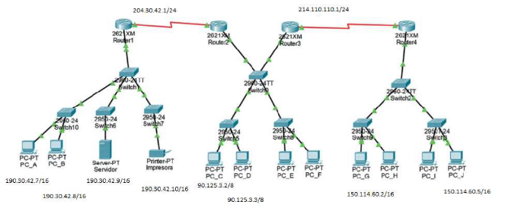
Ejercicio 3

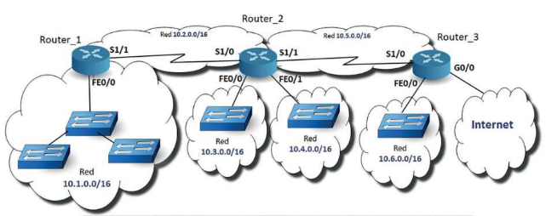
Ejercicio 4

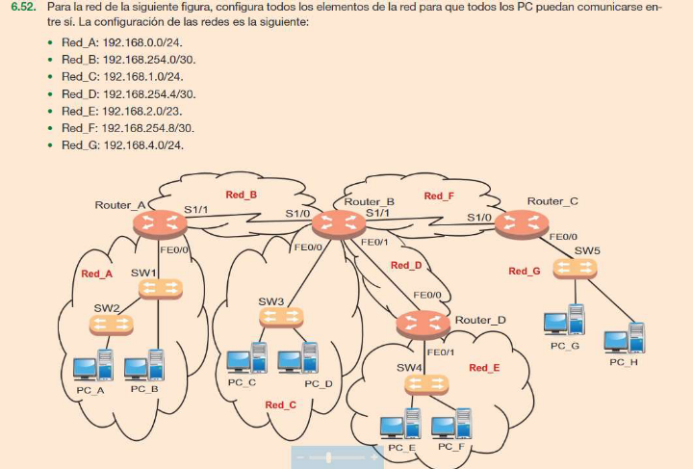
Ejercicio 5

